GYMOS BHUTAN
GYM MEMBERSHIP MANAGEMENT
& POINT OF SALE PLATFORM
PRODUCT CONCEPT AND REQUIREMENTS DOCUMENT
Version 1.0
November 2026
Initial target market: Bhutan
A centralised digital platform for membership, attendance,
sales, inventory and fitness business operations.

Document Information
Particular | Description
Proposed product | GymOS Bhutan
Product category | Gym Membership Management and Point of Sale (POS)
Target market | Bhutan initially, with potential for regional expansion
Business model | Software as a Service (SaaS)
Platforms | Web, Android and iOS
Primary users | Platform administrators, gym owners, gym administrators, receptionists, trainers and members
Currency | Bhutanese Ngultrum (BTN)
Document version | 1.0
Document status | Initial product concept and requirements baseline

Document Purpose
This document outlines the proposed product vision, target customers, functional modules, user roles, technical architecture, business model, implementation roadmap and future opportunities for GymOS Bhutan. It is intended to support product planning, stakeholder discussions, technical design and early commercial validation.

Contents
- 1. Introduction
- 2. Vision and Objectives
- 3. Target Customers
- 4. Functional Modules
- 5. User Roles and Access Control
- 6. Multi-Tenant SaaS Architecture
- 7. Bhutan-Specific Requirements
- 8. Technical Architecture and Technology Stack
- 9. Offline POS Functionality
- 10. Business Model and Subscription Plans
- 11. Implementation Roadmap
- 12. Security and Data Protection
- 13. Future Enhancements
- 14. Expected Business Benefits
- 15. Conclusion and Strategic Recommendations

1. Introduction
GymOS Bhutan is a proposed integrated Gym Membership Management and Point of Sale (POS) platform designed to digitise and simplify the day-to-day operations of gyms, fitness centres and sports clubs in Bhutan.
The platform will provide a centralised solution for managing gym memberships, member registrations, subscription renewals, attendance tracking, product sales, inventory, payments, staff and financial reporting.
Many small and medium-sized fitness businesses rely on manual records, spreadsheets and separate applications to manage their operations. These practices can result in inefficient membership tracking, payment reconciliation challenges, inaccurate inventory records and limited visibility into business performance.
GymOS Bhutan aims to address these challenges through a user-friendly, secure and scalable digital platform that allows gym owners to manage their entire business from one place.
The system will follow a SaaS-based business model, allowing multiple gyms to register and operate independently within the same platform.

2. Vision and Objectives

2.1 Vision
To become a comprehensive digital management platform for gyms and fitness businesses in Bhutan, enabling business owners to operate efficiently, improve customer experiences and make informed business decisions.

2.2 Objectives
- Digitise gym membership registration and management.
- Simplify membership subscription, renewal and payment processes.
- Automate attendance tracking and membership validation.
- Integrate POS functionality for managing product and service sales.
- Provide accurate inventory and financial management.
- Improve communication between gym owners, staff, trainers and members.
- Provide real-time business insights through dashboards and reports.
- Establish a scalable SaaS platform that can support multiple gyms and branches.

3. Target Customers
The platform will initially target businesses operating in Bhutan's fitness and recreational sector.
Customer category | Description
Independent gyms | Small and privately operated fitness centres.
Fitness centres | Established fitness facilities with multiple membership plans.
Bodybuilding centres | Gyms focused on bodybuilding and strength training.
Sports clubs | Clubs offering membership-based sports facilities.
Hotel gyms | Fitness facilities operated by hotels and resorts.
Multi-branch fitness businesses | Organisations managing multiple gym locations.

The system will accommodate both small gym operators and larger fitness businesses.

4. Functional Modules

4.1 Gym Registration and Organisation Management
This module will allow gym owners to register their businesses and configure their operational environment.
- Gym and organisation registration.
- Business profile management.
- Branch registration and management.
- Gym contact information and operating hours.
- Business logo and branding configuration.
- Subscription plan management.
- Gym-specific system configuration.
- Multiple branch management.
- Business activation and deactivation.
Each registered gym will have an independent workspace, with access restricted to its authorised users.

4.2 Membership Management
Membership management will be one of the core modules of the platform. It will support members and their subscriptions throughout the complete membership lifecycle.

Member registration and profiles
- Register new gym members and maintain personal information and contact details.
- Upload member photographs and generate unique member IDs.
- Generate individual QR codes for digital identification and gym access.
- Maintain emergency contact information.
- View membership and payment history.

Membership plan management
Gym administrators will be able to create and configure different membership packages, including:
- Daily membership
- Weekly membership
- Monthly membership
- Quarterly membership
- Six-month membership
- Annual membership
- Custom membership packages
Each plan will have configurable pricing, duration, benefits and applicable conditions.

Membership lifecycle management
- New membership activation and renewal.
- Membership extension, suspension or freezing.
- Membership cancellation and transfer, subject to gym policy.
- Membership expiry tracking and automated expiry notifications.
- Membership history and audit records.
The system will automatically validate membership status during gym entry. Members with expired or suspended memberships will not be permitted to check in unless an authorised staff member grants an exception.

4.3 Attendance and Access Management
This module will automate the process of recording and monitoring gym attendance.

Supported attendance methods
- QR code scanning
- Member ID entry
- Staff-assisted check-in
- RFID card integration
- Biometric access integration as a future enhancement

Key functionalities
- Member check-in and check-out.
- Automatic membership validation.
- Attendance history and daily attendance reports.
- Monthly attendance statistics and member visit frequency.
- Peak-hour attendance analysis.
- Duplicate check-in prevention.
- Access logs and exception tracking.
Gym administrators will be able to monitor attendance and understand member engagement patterns.

4.4 Point of Sale (POS) Management
The POS module will enable gyms to sell products and services directly through the platform. Receptionists will be able to manage membership payments and retail sales using a unified checkout interface.
Products and services may include:
- Protein supplements and protein shakes.
- Energy drinks and bottled water.
- Gym accessories, workout gloves and belts.
- Gym merchandise.
- Personal training sessions.
- Other gym-related products and services.

POS functionalities
- Product catalogue and category management.
- Barcode scanning and quick checkout.
- Shopping cart and product quantity selection.
- Discount and promotional pricing management.
- Multiple payment methods.
- Invoice and receipt generation.
- Refund and transaction cancellation workflows.
- Sales history and daily sales summaries.
- Cashier-wise sales tracking.
Membership payments and retail sales will be processed through the same platform while maintaining separate transaction categories for accurate financial reporting.

4.5 Inventory Management
The inventory module will help gym owners monitor products, purchases and available stock.
- Product registration and categorisation.
- Supplier management.
- Purchase order management.
- Stock-in and stock-out tracking.
- Automatic stock deduction after POS transactions.
- Manual stock adjustments.
- Low-stock notifications.
- Product expiry tracking.
- Inventory valuation.
- Stock movement history.
- Purchase and sales reports.
For example, when a receptionist sells a protein shake through the POS system, the corresponding product quantity will automatically be deducted from available inventory.

4.6 Financial Management
The financial management module will provide gym owners with a consolidated view of business income, expenses and financial performance.

Revenue management
- Membership and renewal revenue
- Retail sales revenue
- Personal training revenue
- Other service revenue
- Outstanding payments
- Payment history

Expense management
- Operational expenses
- Staff payments
- Equipment purchases
- Utility expenses
- Supplier payments
- Maintenance expenses
- Other business expenses

Financial reporting
- Daily, weekly and monthly revenue reports.
- Membership revenue analysis.
- POS sales analysis.
- Expense summaries.
- Cash reconciliation.
- Profit and loss reports.
- Payment collection reports.
- Outstanding payment reports.
The platform will support Bhutanese Ngultrum (BTN) and configurable tax settings.

4.7 Staff and Trainer Management
This module will help gym owners manage employees, receptionists and fitness trainers.

Staff management
- Staff registration and profile management
- Role and permission assignment
- Staff attendance
- Staff activity logs
- Account activation and deactivation

Trainer management
- Trainer profiles and specialisations
- Trainer availability
- Member assignment
- Personal training schedules
- Training session records
- Trainer performance tracking
- Commission management
Gym administrators will be able to assign appropriate permissions to each staff member based on their responsibilities.

4.8 Member Mobile Application
A dedicated mobile application will provide gym members with direct access to their membership information and services.
- Member registration and login.
- Personal profile management.
- Membership status and expiry information.
- Digital membership card and QR code for gym access.
- Membership renewal and payment history.
- Attendance history.
- Workout schedules and trainer information.
- Membership expiry reminders.
- Gym announcements and notifications.
The application will improve communication between gyms and their members while reducing the need for members to visit reception for basic membership information.

5. User Roles and Access Control
The platform will implement role-based access control (RBAC) to ensure that users can only access functionalities relevant to their responsibilities.
User role | Main responsibilities
Platform Super Administrator | Manage the overall SaaS platform, registered gyms and subscriptions.
Gym Owner | Manage gym operations, finances, staff, memberships and reports.
Gym Administrator | Manage daily gym operations and configurations.
Receptionist | Register members, process payments, sell products and manage attendance.
Trainer | View assigned members and manage training schedules.
Gym Member | Access personal membership information and gym services.

Permissions will be configurable. Sensitive operations such as refunds, financial adjustments and membership overrides will be restricted to authorised personnel.

6. Multi-Tenant SaaS Architecture
GymOS Bhutan will be developed using a multi-tenant architecture. Multiple gyms will use the same application and infrastructure while maintaining independent business environments.
For example, Gym A will manage its own members, employees, memberships, sales and financial records, while Gym B will manage its own separate records. Neither gym will be able to access the other's confidential business information.
Each organisation and its branches will have appropriate data isolation. The architecture should support future expansion without requiring a separate application deployment for every gym.
A tenant identifier such as organisation_id or gym_id should be associated with all tenant-owned business records. Database-level access controls and backend authorisation checks must enforce tenant boundaries.

7. Bhutan-Specific Requirements
The system will be designed to accommodate local business practices and payment requirements in Bhutan.
Area | Proposed functionality
Currency | Bhutanese Ngultrum (BTN).
Payments | Cash, bank transfers and supported digital payment methods.
Language | English initially, with future Dzongkha support.
Invoicing | Configurable Bhutan-compatible invoice and receipt formats.
Notifications | Push notifications, SMS and WhatsApp where supported.
Tax | Configurable tax rates and reporting.
Date and time | Bhutan Standard Time (UTC+6).
Connectivity | Offline-capable POS with synchronisation.
Reporting | Business, sales, membership and financial reports.

Payment gateway integrations will depend on the availability of suitable providers, their technical APIs and commercial agreements. The platform should maintain appropriate transaction records to support applicable Bhutanese accounting and tax requirements.

8. Technical Architecture and Technology Stack
The following technology stack is proposed for initial planning. Final selections should be confirmed during technical design and proof-of-concept activities.
Component | Proposed technology
Web frontend | React.js
Mobile application | Flutter
Backend | Spring Boot
Database | PostgreSQL
Authentication | JWT-based authentication
File storage | S3-compatible object storage
API communication | REST APIs
Real-time updates | WebSocket
Deployment | Docker and cloud infrastructure
POS offline storage | IndexedDB or an appropriate local database
Notifications | Firebase Cloud Messaging
Version control | Git

The backend will follow a modular architecture, separating membership, POS, inventory, financial management, attendance and notification functionalities.
The initial deployment should use a modular monolith architecture to simplify development and maintenance. Individual services can be separated later if business growth and system load justify it.

9. Offline POS Functionality
Offline POS functionality will be important for businesses experiencing unstable internet connectivity. The system should allow authorised receptionists to continue selected POS operations during temporary internet interruptions.

Offline capabilities
- Access locally cached product information.
- Create sales transactions.
- Generate temporary receipts.
- Maintain local transaction records.
- Synchronise transactions when connectivity is restored.
The synchronisation mechanism must ensure transaction uniqueness, prevent duplicate submissions and maintain a complete audit trail. Sensitive operations, including membership activation and access validation, should have clearly defined offline rules to prevent unauthorised access.

10. Business Model and Subscription Plans
GymOS Bhutan will follow a subscription-based SaaS business model. Gym owners will subscribe to the platform based on their operational requirements and selected package.
The following pricing structure is proposed for initial market validation. These figures are hypotheses for discussion and are not established Bhutan market prices.
Package | Proposed monthly price | Target customers
Starter | Nu. 499 | Small gyms
Standard | Nu. 999 | Medium-sized gyms
Professional | Nu. 1,999 | Established fitness centres
Enterprise | Custom pricing | Multi-branch organisations

10.1 Indicative Package Differentiation
Feature | Starter | Standard | Professional | Enterprise
Member management | Yes | Yes | Yes | Yes
Membership renewals | Yes | Yes | Yes | Yes
Attendance tracking | Yes | Yes | Yes | Yes
POS | Basic | Yes | Yes | Yes
Inventory | Limited | Yes | Yes | Yes
Financial reports | Basic | Advanced | Advanced | Advanced
Staff management | Limited | Yes | Yes | Yes
Member mobile app | Optional | Yes | Yes | Yes
Multiple branches | No | No | Limited | Yes
Advanced analytics | No | Limited | Yes | Yes

10.2 Additional Revenue Opportunities
- Initial setup and onboarding fees.
- Additional branch subscriptions.
- POS hardware and installation.
- QR and RFID access-control equipment.
- Custom integrations.
- Premium reporting and analytics.
- Additional storage and premium services.
Final pricing, package limits and included services should be determined after discussions with potential customers and an assessment of operating costs.

11. Implementation Roadmap
The platform will be developed incrementally to ensure that essential business operations are functional before advanced features are introduced.
Phase | Scope | Priority
Phase 1 – Core management | Organisation, members, membership plans, renewals, attendance and payment records. | Critical
Phase 2 – POS and inventory | POS, product management, inventory and sales reporting. | High
Phase 3 – Business operations | Financial management, expenses, staff and trainer management. | High
Phase 4 – Member application | Member mobile application, digital membership cards and notifications. | Medium
Phase 5 – Advanced capabilities | RFID, biometric access, advanced analytics and multi-branch enhancements. | Future

11.1 Pilot Implementation
Before commercial launch, the platform should be tested with two to three gyms. The pilot programme will help validate:
- Actual membership management workflows.
- POS usability and payment collection processes.
- Inventory accuracy.
- Staff requirements and access permissions.
- Reporting expectations.
- Subscription pricing and willingness to pay.
- Customer feedback and operational improvements.
Feedback from pilot customers will guide refinements before a wider rollout across Bhutan.

12. Security and Data Protection
The platform will implement appropriate security measures to protect gym businesses and their members.
- Secure authentication and authorisation.
- Role-based access control.
- Tenant-level data isolation.
- Encrypted communication using HTTPS.
- Secure password storage.
- Audit logs for sensitive transactions.
- Database backup and recovery procedures.
- Secure payment transaction records.
- Protection of personal information.
- Session management and account security.
- Monitoring of suspicious activities.
Financial transactions should be immutable from an audit perspective. Corrections should be recorded through authorised reversals or adjustments rather than silently modifying historical transactions.

13. Future Enhancements

13.1 Fitness and Health Tracking
- Member fitness assessments.
- Weight and body measurement records.
- Fitness progress tracking.
- Workout plans.
- Trainer feedback.

13.2 Automated Membership Marketing
- Membership expiry campaigns.
- Renewal reminders.
- Promotional notifications.
- Member retention analytics.
- Referral programmes.
- Discount campaigns.

13.3 Advanced Access Control
- RFID card readers.
- Biometric devices.
- Automated access gates.
- Integration with compatible gym access-control hardware.

13.4 Advanced Business Intelligence
- Member growth analysis.
- Membership retention rates.
- Revenue trends.
- Product performance.
- Peak-hour analysis.
- Trainer performance.
- Branch-wise comparisons.

13.5 Expansion Beyond Gyms
The underlying membership and POS architecture could eventually be extended to other membership-based businesses, including:
- Sports associations.
- Recreation clubs.
- Swimming centres.
- Martial arts centres.
- Yoga and wellness centres.
- Other subscription-based organisations.
This would allow the product to evolve into a broader membership and business management platform.

14. Expected Business Benefits

14.1 Benefits for Gym Owners
- Centralised management of business operations.
- Improved visibility into revenue and expenses.
- Better control over memberships and payments.
- Accurate inventory management.
- Reduced administrative workload.
- Data-driven business decisions.

14.2 Benefits for Gym Staff
- Simplified member registration.
- Faster checkout and payment processing.
- Easier attendance management.
- Reduced manual recordkeeping.

14.3 Benefits for Gym Members
- Convenient digital membership access.
- Faster gym check-in.
- Easy membership renewal.
- Transparent payment history.
- Better communication with gym management.

15. Conclusion and Strategic Recommendations
GymOS Bhutan aims to provide a comprehensive and scalable digital solution for the fitness industry in Bhutan.
By combining membership management, attendance tracking, POS, inventory management, financial reporting and member engagement into a single platform, the system will help fitness businesses modernise their operations and improve service delivery.
The SaaS-based approach will allow the platform to serve businesses of different sizes while maintaining independent organisational environments.
The initial focus should be on establishing a reliable membership management and POS solution, followed by the gradual introduction of mobile applications, advanced reporting, access-control integrations and additional business management capabilities.
The long-term objective is to establish GymOS Bhutan as a trusted digital platform for gym and fitness business operations, with the potential to expand into other membership-based industries.

15.1 Recommended Next Steps
- Confirm the product scope: decide whether the first release will serve gyms only or include other membership-based organisations.
- Conduct commercial validation: interview at least three to five gym owners to understand their current registration, renewal, payment, attendance and sales processes.
- Define the minimum viable product (MVP): prioritise membership management, QR attendance, payment collection and POS.
- Prepare the Software Requirements Specification (SRS): document functional requirements, user stories, business rules, database design, API specifications and screen-by-screen UI requirements.
- Build and test a pilot: onboard two to three gyms, collect feedback and refine the product before commercial launch.

Appendix A – Initial MVP Scope
The following capabilities are recommended for the first commercially testable release:
MVP area | Minimum capabilities
Organisation setup | Register a gym, configure its profile and create initial staff accounts.
Members | Register, update, search and view member profiles.
Membership | Create plans, activate memberships, renew, extend, freeze and track expiry.
Attendance | QR/member ID check-in, membership validation and attendance history.
Payments | Record membership payments, issue receipts and view payment history.
POS | Create products, process sales, record payment and issue receipts.
Inventory | Track stock balances and deduct stock for completed POS sales.
Reports | Basic membership, attendance, payment and sales summaries.
Administration | Role-based permissions, audit logs and tenant data isolation.

Appendix B – Important Product Decisions to Confirm
- Whether the initial product is gym-only or a general membership platform.
- Whether POS will be included in every subscription tier or offered as an add-on.
- Which payment providers and bank integrations are technically and commercially available.
- Whether each gym requires one branch or multiple branches at launch.
- Which POS hardware (receipt printers, barcode scanners and cash drawers) should be supported first.
- Which membership policies should be configurable by each gym.
- How offline transactions, refunds and synchronisation conflicts will be handled.
- Which reports and invoice fields are required by pilot customers and applicable local requirements.

Appendix C – Complete System Flow Diagrams
The following diagrams describe the principal operational workflows proposed for GymOS Bhutan. They are intended as a product-planning baseline and should be validated against pilot-gym policies, payment-provider capabilities and detailed requirements during the SRS phase.

C1. End-to-End Platform Overview
Shows how organisation onboarding connects to membership, attendance, POS, inventory, reporting and member-facing services.
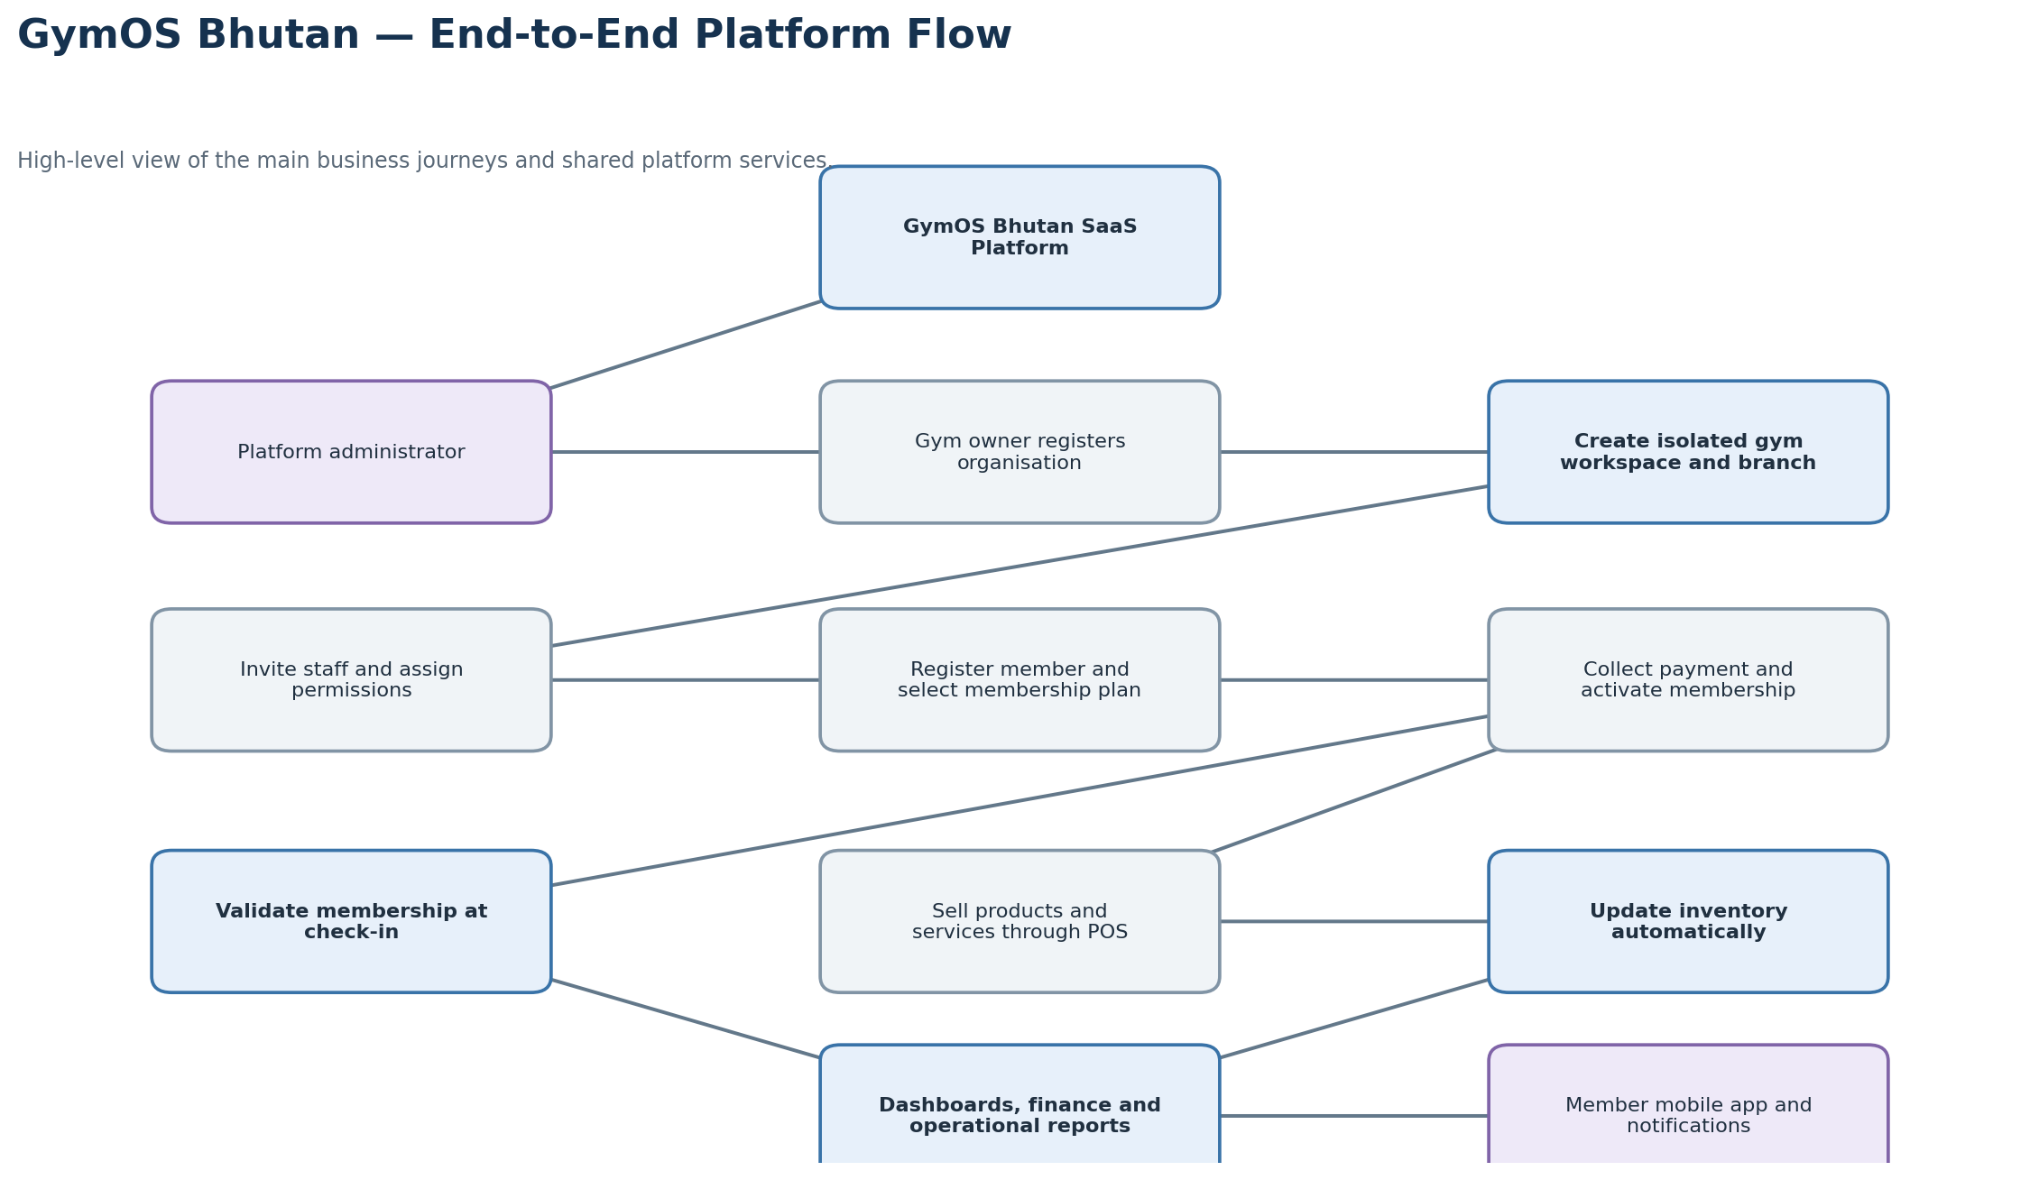

C2. Gym Registration, Tenant Setup and Subscription
Shows owner registration, verification, plan selection, tenant workspace creation, branch setup and staff provisioning.
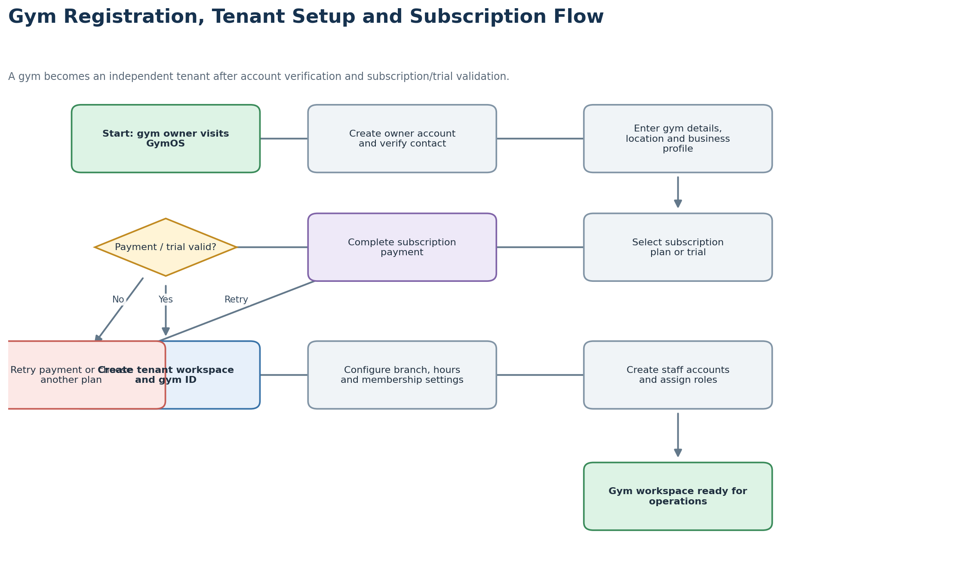

C3. Member Registration and Membership Lifecycle
Shows member capture, plan selection, payment confirmation, activation, renewal, freezing, expiry and cancellation.
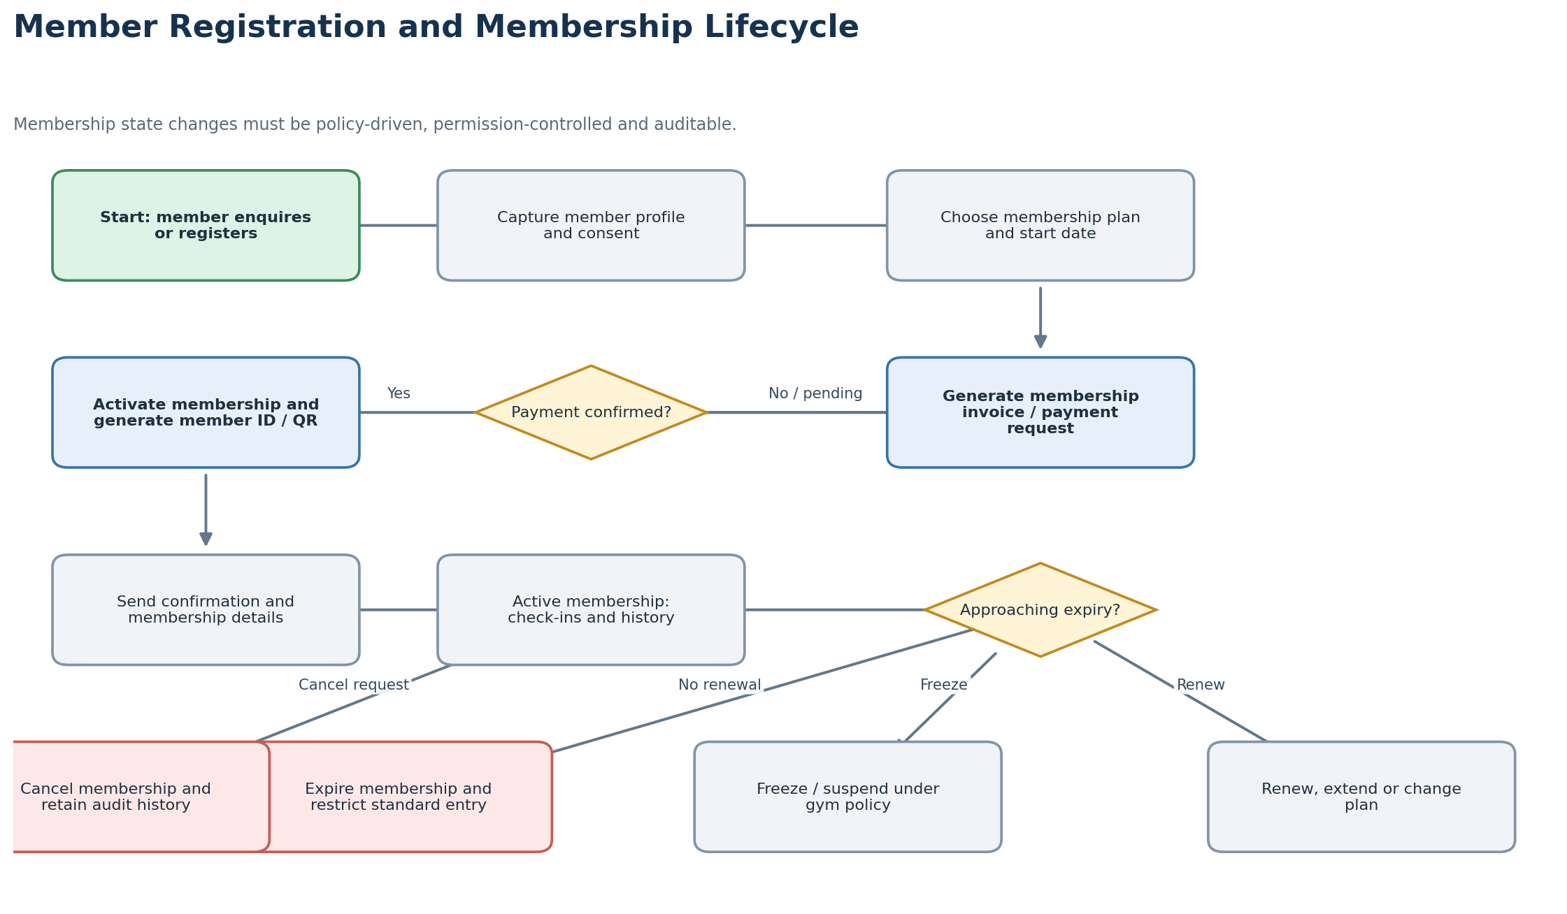

C4. Gym Attendance and Access Validation
Shows QR/member ID/RFID check-in, membership validation, access decisions and controlled staff overrides.
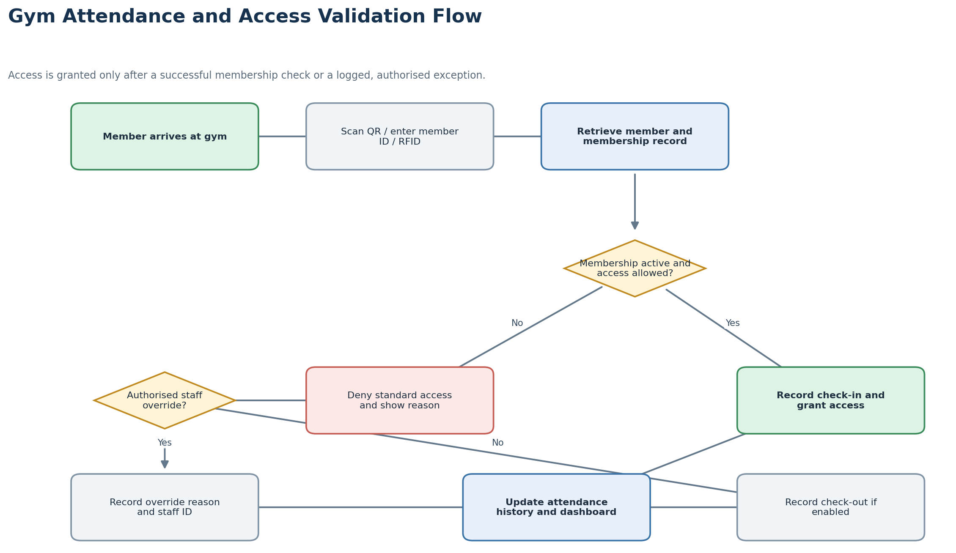

C5. POS Checkout, Payment and Inventory
Shows product selection, stock validation, payment, receipt generation, stock movement and reporting.
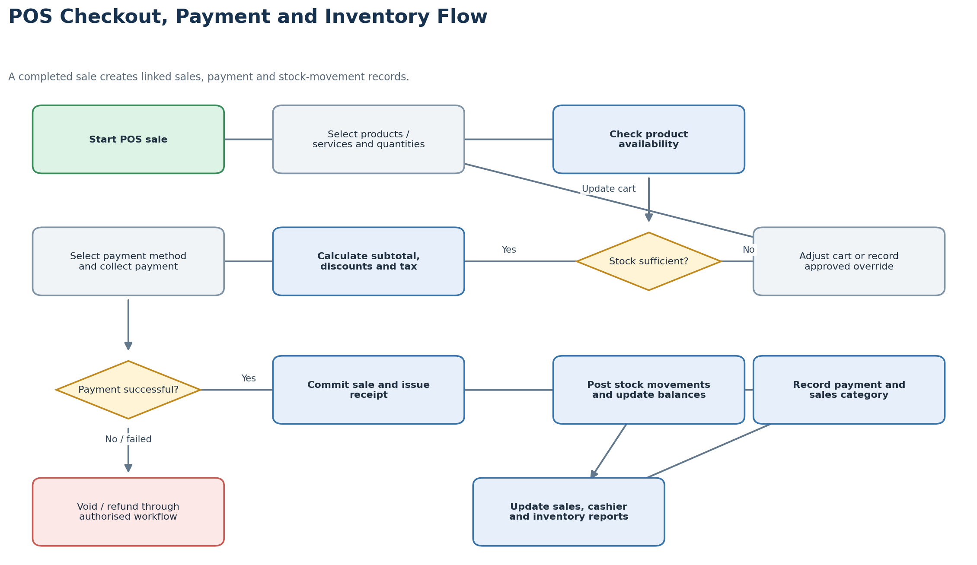

C6. Offline POS Synchronisation and Reporting
Shows local transaction queuing, synchronisation, duplicate detection, exception handling and financial reporting.
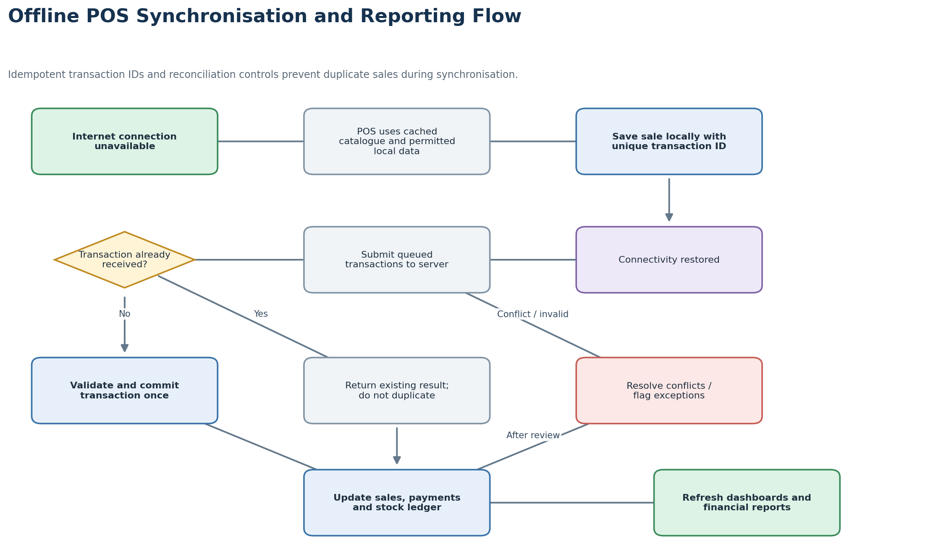

Appendix D – Flow Diagram Legend and Key Business Rules
Diagram element | Meaning
Rounded green box | Start or successful end of a workflow.
Blue box | System action, validation or automated processing.
Grey box | User or staff process.
Diamond | Decision point; outgoing paths are labelled with outcomes.
Red box | Exception, denial, failure or controlled reversal.
Purple box | External actor or external service interaction.

Key business rules to confirm during detailed design
- Membership activation should occur only after payment confirmation or an authorised complimentary/credit workflow.
- Membership expiry, freezing, suspension, cancellation and transfer rules must be configurable by each gym within platform guardrails.
- Expired or suspended memberships should fail standard access validation; any override must capture the authorising staff member and reason.
- A POS sale should update inventory only when the sale reaches the defined committed state. Failed or abandoned checkouts must not deduct stock.
- Refunds and voids should create traceable reversal records and, where applicable, restore inventory through a separate stock movement.
- Offline POS transactions must use unique identifiers and idempotent server processing to prevent duplicate posting.
- Tenant and branch access must be enforced in both backend authorisation and database access controls.
- Payment-provider callbacks and manual payment confirmations must be verified and recorded before a transaction is treated as settled.
- Financial reports should distinguish membership revenue, retail sales, service revenue, refunds, discounts, taxes and expenses.

